**SERVLET ASSIGNMENT -03 prajwal_77**

**1.Create a servlet that prints WELCOME TO SERVLET WORLD using html&**

**heading tag.**

**package com.prajwal;**

**import jakarta.servlet.ServletException;**

**import jakarta.servlet.http.HttpServlet;**

**import jakarta.servlet.http.HttpServletRequest;**

**import jakarta.servlet.http.HttpServletResponse;**

**import java.io.IOException;**

**import java.io.PrintWriter;**

**public class HelloServlet extends HttpServlet {**

**private static final long serialVersionUID = 1L;**

**public HelloServlet() {**

**super();**

**// TODO Auto-generated constructor stub**

**}**

**protected void service(HttpServletRequest req, HttpServletResponse res)**

**throws ServletException, IOException {**

**res.setContentType("text/html");**

**PrintWriter out = res.getWriter();**

**out.print("WELCOME TO THE SERVLET WORLD");**

**}**

**}**

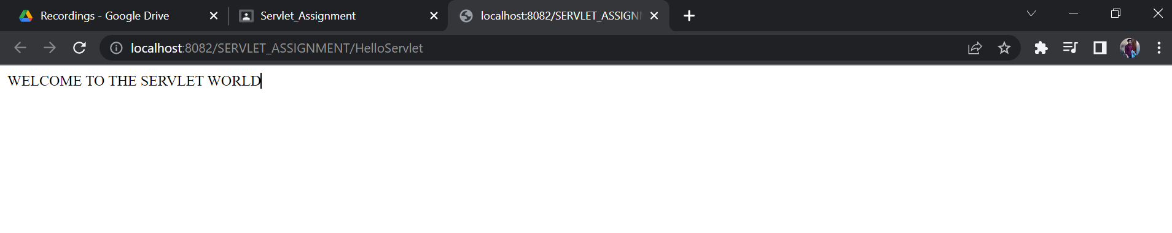

**2. Create a servlet that displays system date in the dd/mm/yyyy  format.**

**package com.cdac.servlet;**

**import java.io.IOException;**

**import java.io.PrintWriter;**

**import java.time.LocalDate;**

**import jakarta.servlet.ServletException;**

**import jakarta.servlet.annotation.WebServlet;**

**import jakarta.servlet.http.HttpServlet;**

**import jakarta.servlet.http.HttpServletRequest;**

**import jakarta.servlet.http.HttpServletResponse;**

**@WebServlet("/helloServlet")// url**

**public class helloServlet extends HttpServlet {**

**private static final long serialVersionUID = 1L;**

**protected void doGet(HttpServletRequest request, HttpServletResponse response) throws ServletException, IOException {**

**response.setContentType("text/html");**

**PrintWriter out = response.getWriter();**

**out.write("<html><body>");**

**out.write("<h1>Hello Again </h1>");**

**out.write("<h2>Today's Date is " + LocalDate.now()+"</h2>");**

**out.write("</body><html>"); }**

**}**

**OUTPUT-**

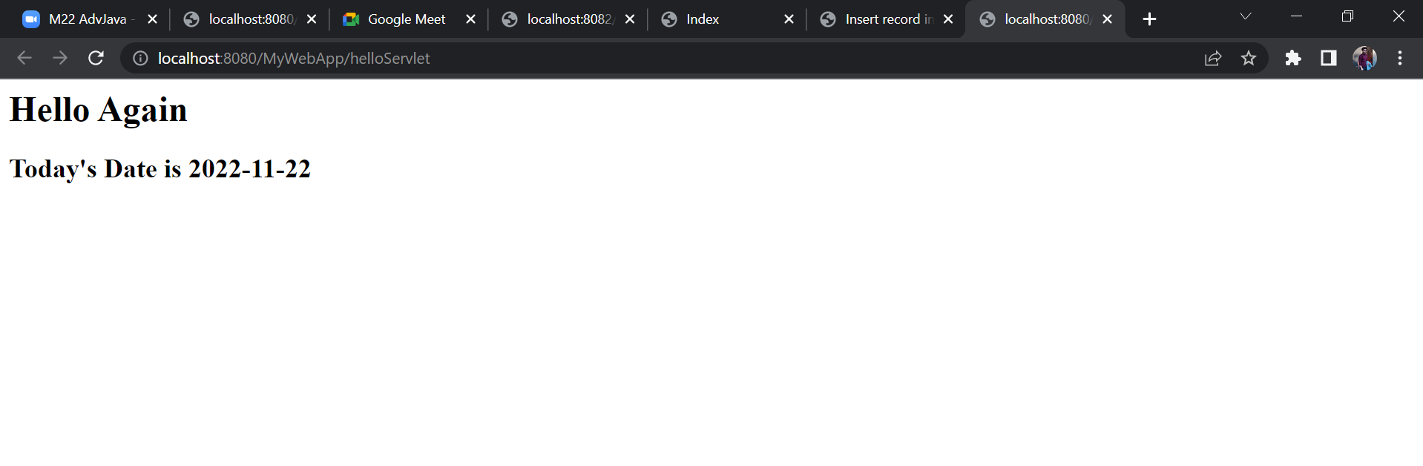

**.3. Create a servlet that prints following error message using red color**

**font.“CREATING GUI IS COMPLEX USING SERVLET”.**

package serv;

import java.io.IOException;

import java.io.PrintWriter;

import jakarta.servlet.ServletException;

import jakarta.servlet.annotation.WebServlet;

import jakarta.servlet.http.HttpServlet;

import jakarta.servlet.http.HttpServletRequest;

import jakarta.servlet.http.HttpServletResponse;

*@WebServlet*("/Red")

public class RedFont extends HttpServlet {

private static final long ***serialVersionUID*** = 1L;

protected void service(HttpServletRequest request, HttpServletResponse response) throws ServletException, IOException {

response.setContentType("text/html");

PrintWriter out = response.getWriter();

out.println("<html><body text='red'><h1>CREATING GUI IS COMPLEX USING SERVLET</h1></body></html>");

OUTPUT-

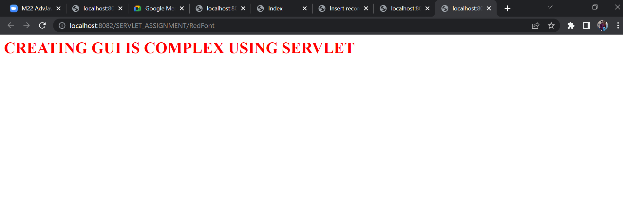

**4.Create an html page having two buttons first labeled with GET REQUEST DEMO and second with POST REQUEST DEMO. Create a Servlet    that overrides both doGet and doPost methods. After clicking first button doGet method should be called that prints “YOU SELECTED GET TYPE REQUEST”. After clicking second button doPost method should be called that prints “YOU SELECTED POST TYPE**

**REQUEST”.**

GetServlet

**1**

package serv;

import java.io.IOException;

import java.io.PrintWriter;

import jakarta.servlet.ServletException;

import jakarta.servlet.annotation.WebServlet;

import jakarta.servlet.http.HttpServlet;

import jakarta.servlet.http.HttpServletRequest;

import jakarta.servlet.http.HttpServletResponse;

*@WebServlet*(value = { "/Get" })

public class GetServlet extends HttpServlet {

private static final long ***serialVersionUID*** = 1L;

protected void doGet(HttpServletRequest request, HttpServletResponse response)

throws ServletException, IOException {

response.setContentType("text/html");

PrintWriter out = response.getWriter();

out.print("<h1>YOU SELECTED GET TYPE REQUEST</h1>");

out.flush();

out.close();

}

PostServlet

}

package serv;

import java.io.IOException;

import java.io.PrintWriter;

import jakarta.servlet.ServletException;

import jakarta.servlet.annotation.WebServlet;

import jakarta.servlet.http.HttpServlet;

import jakarta.servlet.http.HttpServletRequest;

import jakarta.servlet.http.HttpServletResponse;

*@WebServlet*(value = { "/Post" })

public class PostServlet extends HttpServlet {

private static final long ***serialVersionUID*** = 1L;

protected void doPost(HttpServletRequest request, HttpServletResponse response) throws ServletException, IOException {

response.setContentType("text/html");

PrintWriter out = response.getWriter();

out.print("<h1>YOU SELECTED POST TYPE REQUEST</h1>");

out.flush();

out.close();

}

}

index

index.html

<!**DOCTYPE** html>

<**html**>

<**head**>

<**meta** charset=*"ISO-8859-1"*>

<**title**>Insert title here</**title**>

</**head**>

<**body**>

<**form** action=*"Get"* method=*"GET"*>

<**button** type=*"submit"*>GET REQUEST DEMO</**button**>

</**form**>

<**br**>

<**form** action=*"Post"* method=*"post"*>

<**button** type=*"submit"*>POST REQUEST DEMO</**button**>

</**form**>

</**body**>

</**html**>

**1**

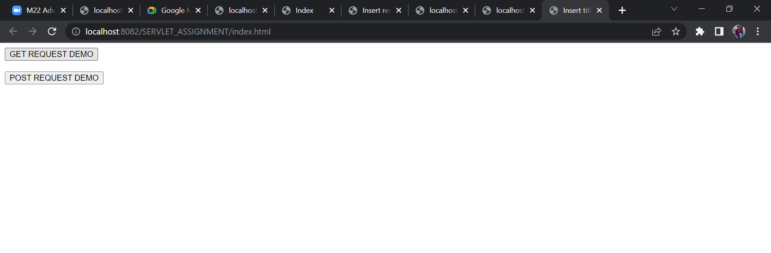

**2**

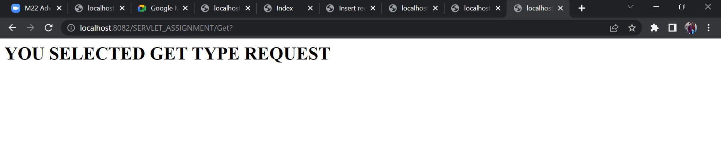

**3**

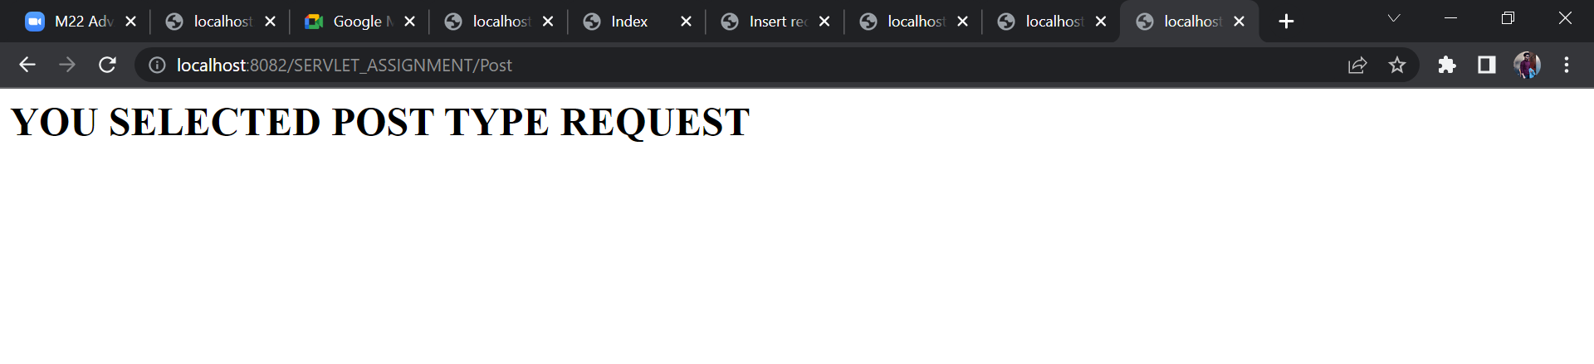

**5. Create an html page that has a textfield to take the user name. After submitting the page Servlet should be called that prints Welcome message with entered name like WELCOME SARJE.**

package serv;

import java.io.IOException;

import java.io.PrintWriter;

import jakarta.servlet.ServletException;

import jakarta.servlet.annotation.WebServlet;

import jakarta.servlet.http.HttpServlet;

import jakarta.servlet.http.HttpServletRequest;

import jakarta.servlet.http.HttpServletResponse;

*@WebServlet*("/Servlet")

public class TextServlet extends HttpServlet {

private static final long ***serialVersionUID*** = 1L;

protected void doPost(HttpServletRequest request, HttpServletResponse response)

throws ServletException, IOException {

String fnm = request.getParameter("fname");

try (PrintWriter out = response.getWriter()) {

response.setContentType("text/html");

out.print("<html>");

out.print("<head>");

out.print("<title>Display Name</title>");

out.print("</head>");

out.print("<body>");

out.println("<h1>" + "Welcome " + fnm + "</h1>");

out.print("</body>");

out.print("</html>");

}

}

Input.html

<!**DOCTYPE** html>

<**html**>

<**head**>

<**meta** charset=*"ISO-8859-1"*>

<**title**>Insert title here</**title**>

</**head**>

<**body**>

<**form** action=*"Servlet"* method=*"post"*>

<**div**>

<**label**> Enter your name </**label**> <**input** type=*"text"* name=*"fname"*>

</**div**>

<**button** type=*"submit"*>Submit</**button**>

</**form**>

</**body**>

</**html**>

}

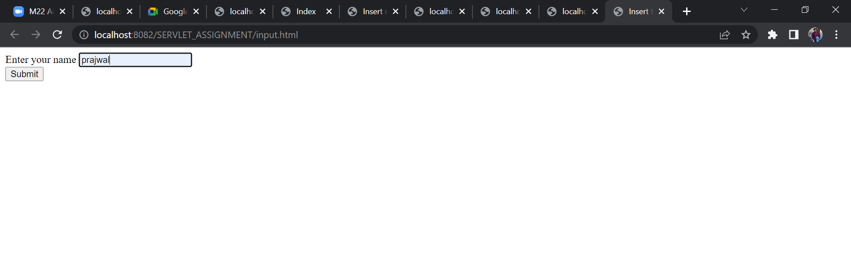

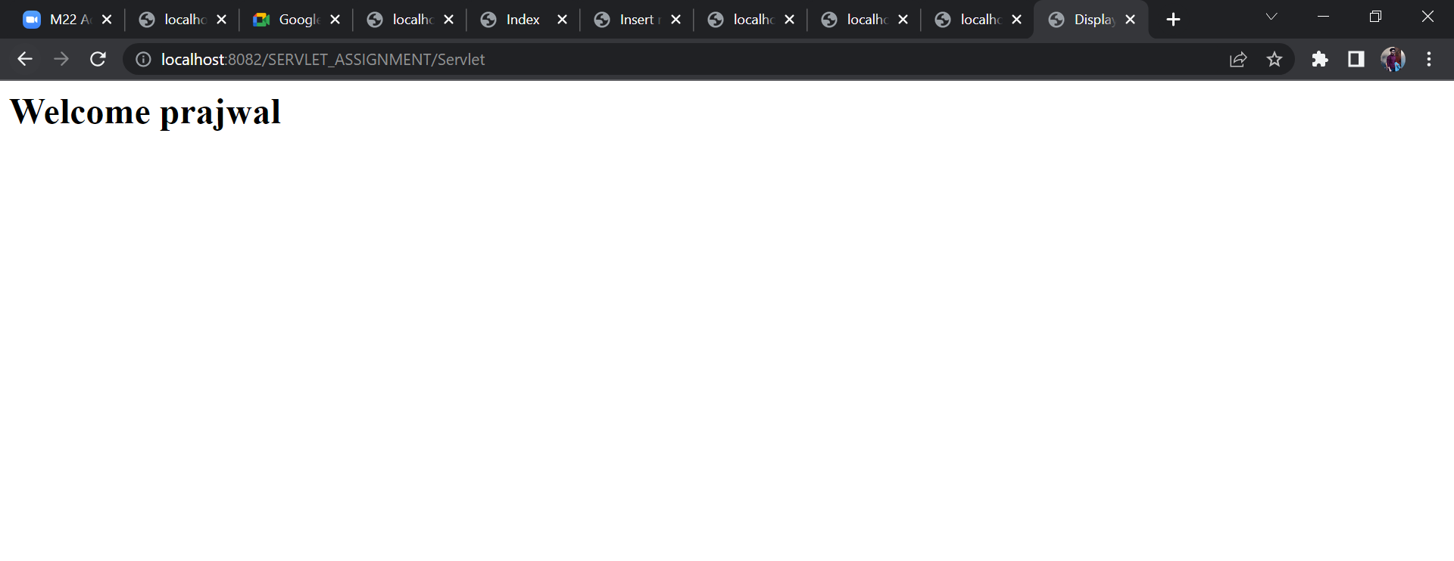

**Q6. CALCULATOR**

OUTPUT-

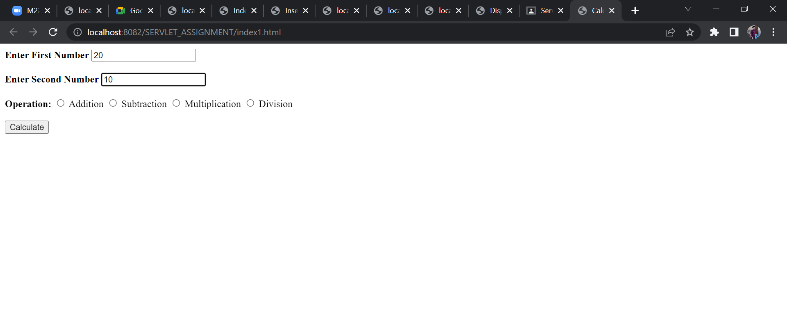

ADDITION-

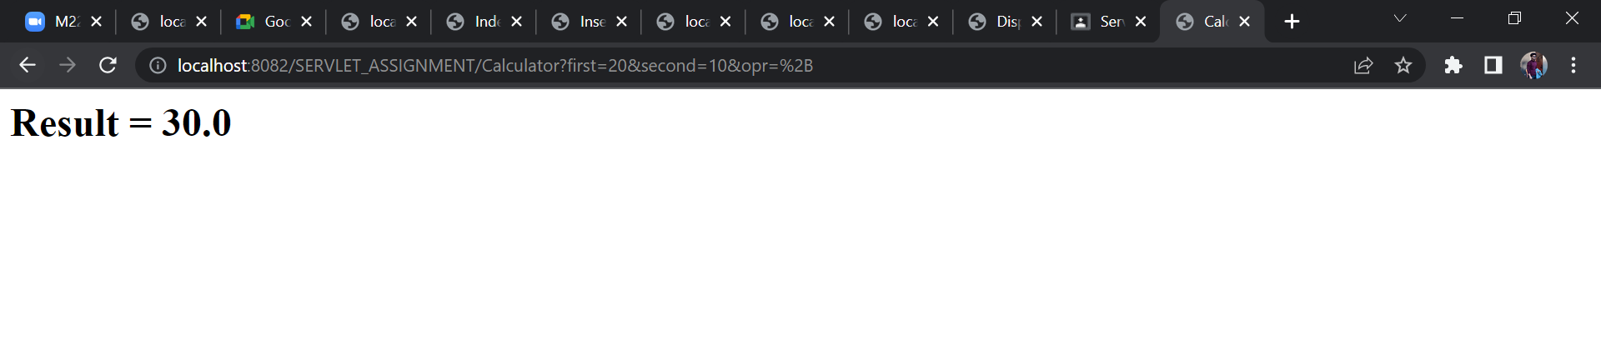

SUBSTRACTION-

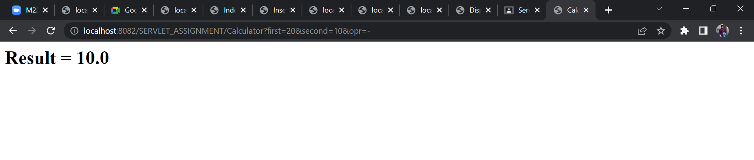

MULTIPLICATION-

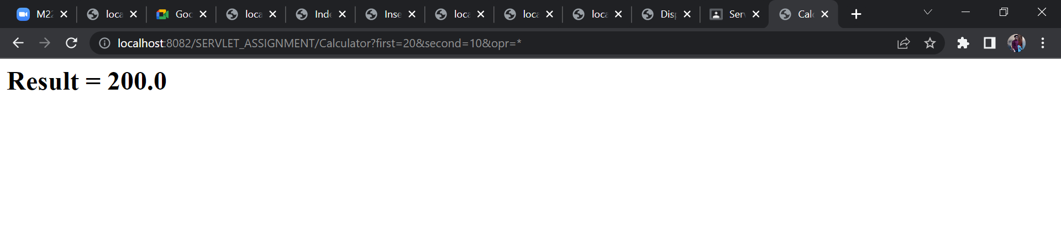

DIVISION-

